Bài 1:

Mới chạy

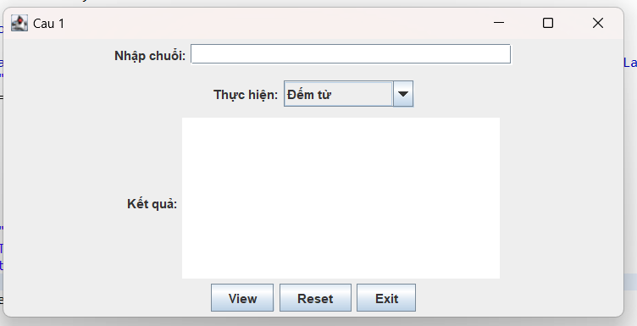

Đếm từ:

Trùng lặp:

Reset:

Bài 2:

Tạo database:

Kết nối database:

Đọc file data1:

File data1:

